**VS2019调试工具使用报告**



**班级：信息类11班**

**学号：2151294**

**姓名：马威**

**完成日期：2021.12.30**

1. **小程序1：**

#include <iostream>

#include <cmath>

using namespace std;

int fun(int num)

{

num++;

return num;

}

int main()

{

int n = 4;

n = fun(n);

double d;

d = sqrt(n);

cout << n << " " << d << " #" << endl;

return 0;

}

**1.1.图1**

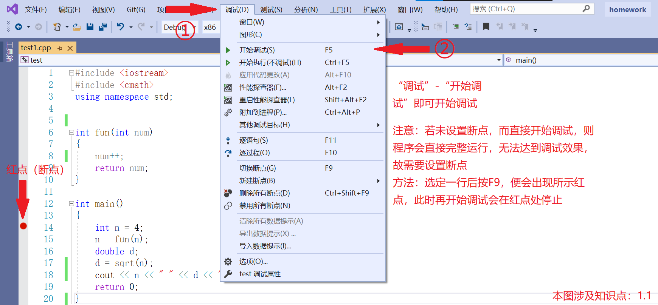

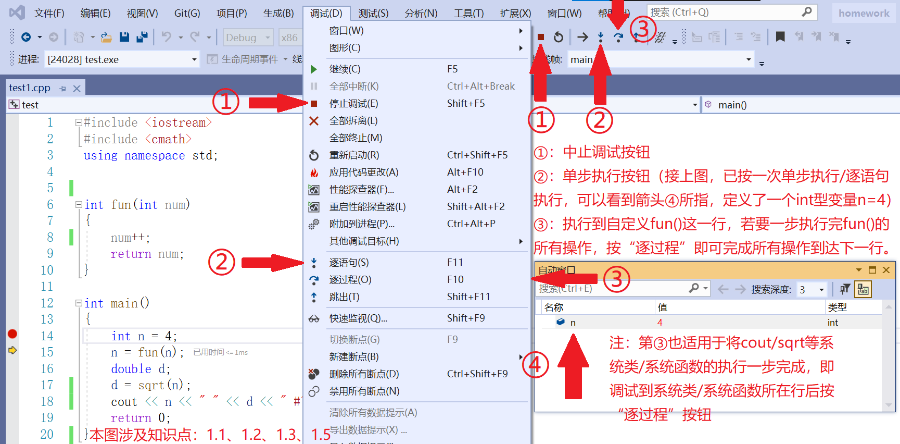**1.2.图2**

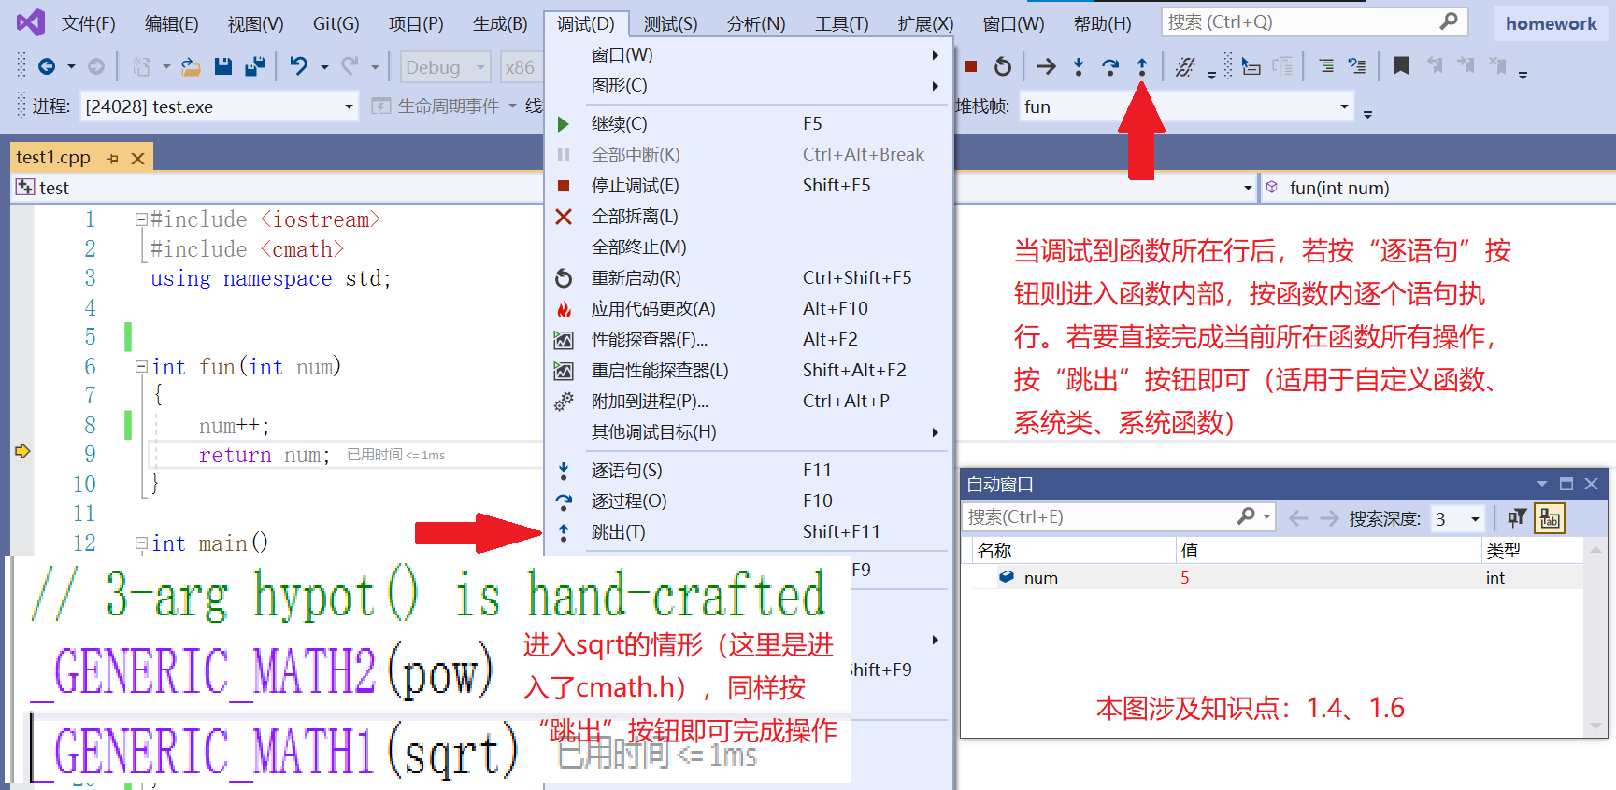**1.3.图3**

**2.小程序2**

#include <iostream>

using namespace std;

void fun(int* NUMBERS, char& ch)

{

int i = 0;

const char String[] = "12345!@#$%", * p5 = String;

const char* p6 = "67890^&*()";

if (ch >= 'a' && ch <= 'z')

ch = ch - 'a' + 'A';

int* p = NUMBERS;

(*p)++;

p++;

(*p)++;

}

int main()

{

int i = 123456, * p1 = &i;

float f = 123.456f, * p2 = &f;

double d = 123.456, * p3 = &d;

cout << *p1 << " " << p1 << endl;

cout << *p2 << " " << p2 << endl;

cout << *p3 << " " << p3 << endl;

int num[3] = { 1,2,3 }, * p4 = num;

char str[3][6] = { "hello","apple","juice" };

char c = 'f';

fun(num, c);

cout << c << endl;

return 0;

}

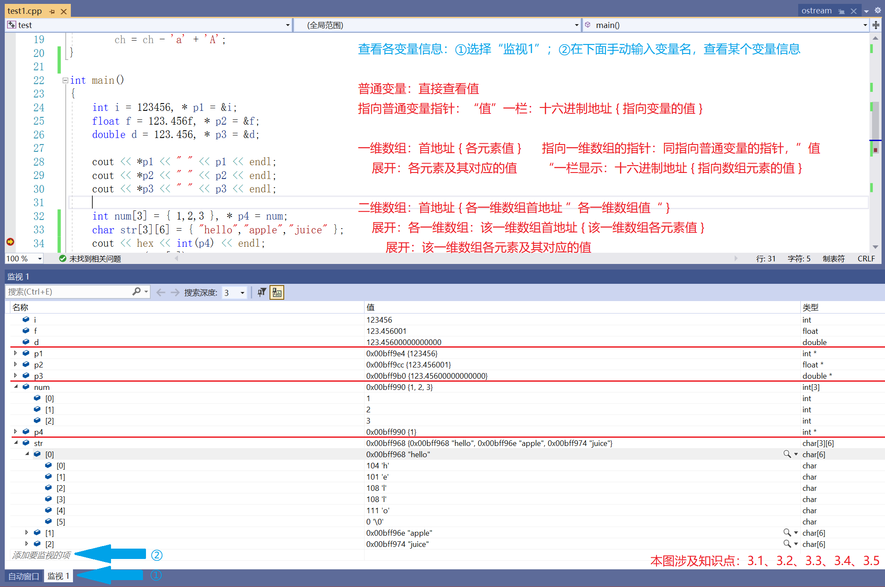**2.1.图1**

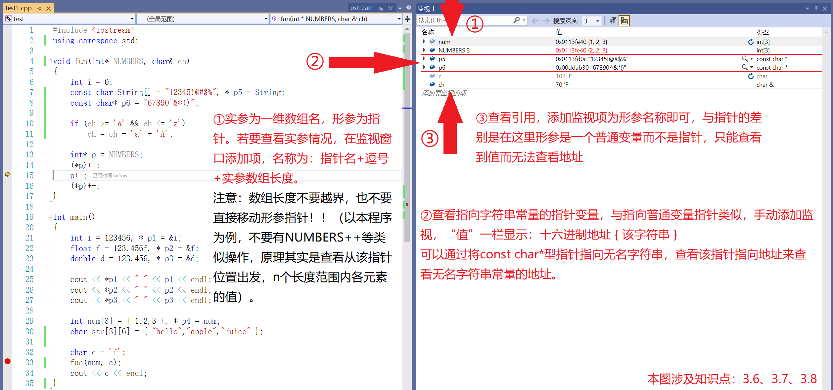**2.2.图2**

**3.小程序3**

**ex1.cpp**

#include <iostream>

using namespace std;

extern int EXTERN;

static int STATIC = 1010;

void fun2(); //提前声明

void fun1(int num)

{

int i = 0;

static int sum = 0;

while (i < 10) {

sum = sum + num;

i++;

}

}

int main()

{

int number = 10;

fun1(number);

cout << STATIC + EXTERN << endl;

fun1(number);

fun2();

return 0;

}

**ex2.cpp**

#include <iostream>

using namespace std;

int EXTERN = 15;

static int STATIC = 2020;

void fun2()

{

EXTERN++;

cout << STATIC + EXTERN << endl;

}

**3.1.图1**

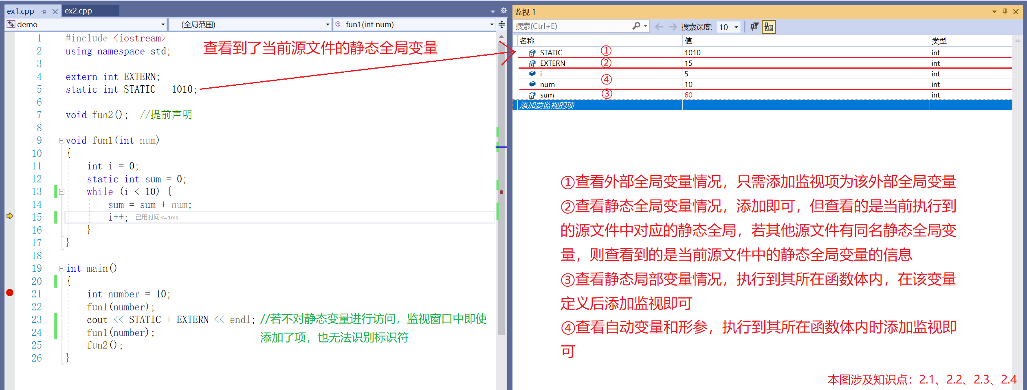

**--------------------------------------------------------------**

**3.2.图2**

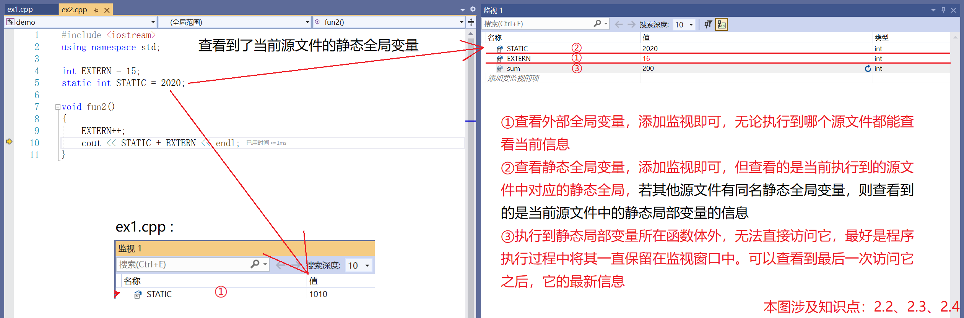

**4.小程序4**

#include <iostream>

using namespace std;

int main()

{

int a[10] = { 1,2,3,4,5,6,7,8,9,10 }, * p1 = a;

while (p1 - a < 15) {

cout << *p1 << " ";

p1++;

}

char c[6] = "house", * p2 = c;

while (p2 - c < 15) {

cout << *p2 << endl;

p2++;

}

}

**4.1.图1**

